**Report For Runlinc**

**(A case study for Traffic Lights)**

By

Afolayan Oluwatimilehin Israel

080-452

**Introduction**

In modern urban environments, traffic lights are essential tools for regulating vehicular and pedestrian traffic flow, ensuring safety and efficiency at intersections. Beyond their practical utility, traffic lights symbolize a critical aspect of urban infrastructure that impacts daily life and transportation systems worldwide. The development of digital simulations of traffic lights not only aids in understanding their operational dynamics but also serves as a valuable educational tool for students and professionals in traffic management and urban planning.

This report explores the design and implementation of a digital simulation of a traffic light using web technologies such as HTML, CSS, and JavaScript. The simulation aims to replicate the behavior of a typical traffic light system, where lights transition through red, yellow, and green phases, simulating the changing signals seen at intersections.

## **Background**

Traffic lights operate on a cyclical basis, following a standardized sequence of colors to control the movement of vehicles and pedestrians. The sequence typically begins with red, indicating a stop for all traffic in the direction governed by the light, followed by yellow, signaling a transition period, and then green, allowing traffic to proceed. This sequence is crucial for managing traffic flow efficiently, minimizing congestion, and ensuring safety at intersections.

Digital simulations of traffic lights provide a practical way to visualize and study their operation without the constraints of physical installation. Such simulations are widely used in educational settings to teach traffic management principles, signal timing strategies, and the impact of traffic light configurations on traffic patterns.

In this project, we develop a web-based traffic light simulation that mimics the behavior of real-world traffic lights. Using HTML for structure, CSS for styling, and JavaScript for dynamic functionality, the simulation allows users to interactively observe and control the sequence of traffic light signals. The goal is to provide an engaging and educational experience that demonstrates the fundamental principles of traffic light operation and management.

**Visual Content**

Below is the screenshot of the HTML, CSS and JavaScript Code:

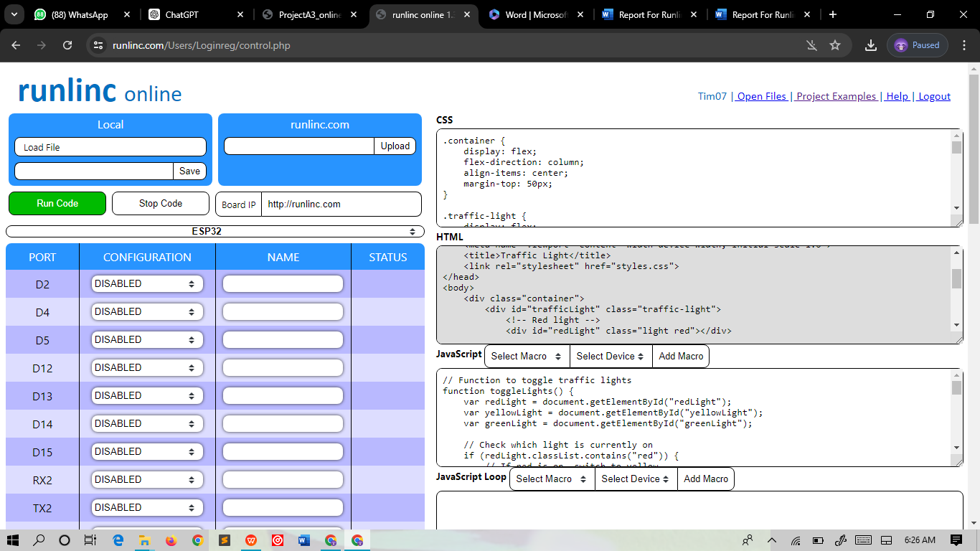

**HTML**

<!DOCTYPE html>

<html lang="en">

<head>

<meta charset="UTF-8">

<meta name="viewport" content="width=device-width, initial-scale=1.0">

<title>Traffic Light</title>

<link rel="stylesheet" href="styles.css">

</head>

<body>

<div class="container">

<div id="trafficLight" class="traffic-light">

<!-- Red light -->

<div id="redLight" class="light red"></div>

<!-- Yellow light -->

<div id="yellowLight" class="light yellow"></div>

<!-- Green light -->

<div id="greenLight" class="light green"></div>

</div>

<button id="controlButton" onclick="toggleLights()">Switch Lights</button>

</div>

<script src="script.js"></script>

</body>

</html>

**CSS**

.container {

display: flex;

flex-direction: column;

align-items: center;

margin-top: 50px;

}

.traffic-light {

display: flex;

flex-direction: column;

align-items: center;

width: 100px;

background-color: #333;

border-radius: 10px;

padding: 10px;

}

.light {

width: 80px;

height: 80px;

border-radius: 50%;

margin: 10px;

}

.red {

background-color: red;

}

.yellow {

background-color: yellow;

}

.green {

background-color: green;

}

#controlButton {

font-size: 18px;

padding: 10px 20px;

margin-top: 20px;

cursor: pointer;

}

**JavaScript**

// Function to toggle traffic lights

function toggleLights() {

var redLight = document.getElementById("redLight");

var yellowLight = document.getElementById("yellowLight");

var greenLight = document.getElementById("greenLight");

// Check which light is currently on

if (redLight.classList.contains("red")) {

// If red is on, switch to yellow

redLight.classList.remove("red");

redLight.classList.add("gray");

yellowLight.classList.remove("gray");

yellowLight.classList.add("yellow");

} else if (yellowLight.classList.contains("yellow")) {

// If yellow is on, switch to green

yellowLight.classList.remove("yellow");

yellowLight.classList.add("gray");

greenLight.classList.remove("gray");

greenLight.classList.add("green");

} else {

// If green is on, switch to red

greenLight.classList.remove("green");

greenLight.classList.add("gray");

redLight.classList.remove("gray");

redLight.classList.add("red");

}

}

// Function to automatically toggle lights every 3 to 5 seconds

function autoToggleLights() {

setInterval(toggleLights, Math.floor(Math.random() * 3001) + 3000); // Random time between 3000 ms (3s) and 6000 ms (6s)

}

// Start automatic toggling when the page loads

autoToggleLights();

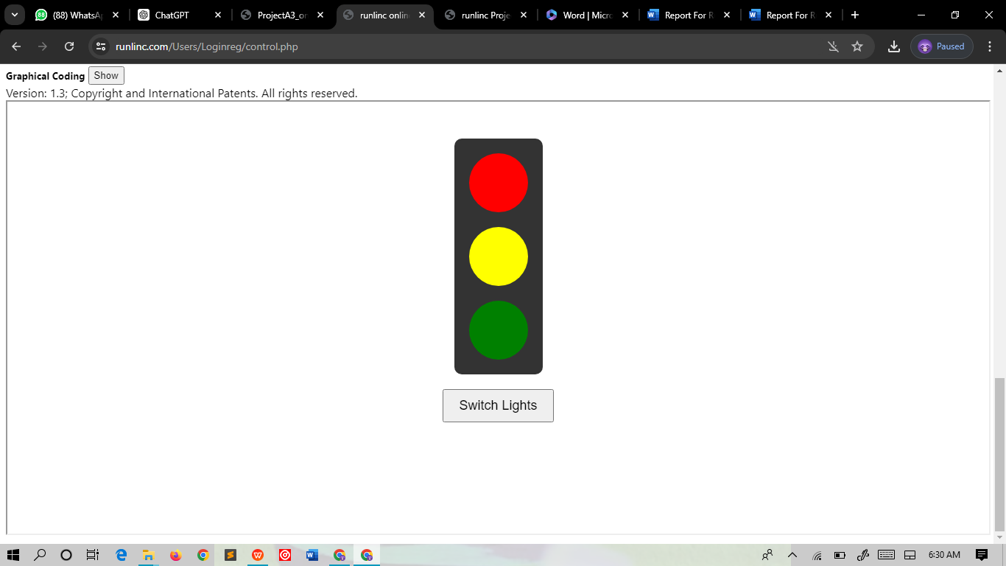

Click on switch button and the Lights switch or wait for 5 seconds for the lights to switch automatically.

